http://www.cnblogs.com/huzi007/p/5602087.html

**[maven 仓库下载缓慢，怎么解决](https://www.cnblogs.com/huzi007/p/5602087.html)**

maven下载jar的时候会去寻国外的地址，因此造成了下载jar很缓慢，影响开发效率，于是就出现maven镜像地址，可以使我们开发人员迅速下载相关的jar。

在maven的config的setting.xml文件中,我们发现:

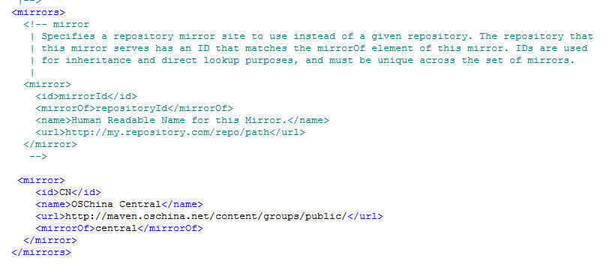

mirror的配置就是为了镜像。

[复制代码](javascript:void(0);)

1 国内连接maven官方的仓库更新依赖库，网速一般很慢，收集一些国内快速的maven仓库镜像以备用。

2

3 ====================国内OSChina提供的镜像，非常不错===================

4

5 <mirror>

6

7 <id>CN</id>

8 <name>OSChina Central</name>

9 <url>http://maven.oschina.net/content/groups/public/</url>

10 <mirrorOf>central</mirrorOf>

11

12 </mirror>

13

14 ========================================================

15

16 OSChina Maven 库使用帮助

17

18

19 ==================其他maven仓库镜像==========================

20

21 <mirror>

22 <id>repo2</id>

23 <mirrorOf>central</mirrorOf>

24 <name>Human Readable Name for this Mirror.</name>

25 <url>http://repo2.maven.org/maven2/</url>

26 </mirror>

27 <mirror>

28 <id>net-cn</id>

29 <mirrorOf>central</mirrorOf>

30 <name>Human Readable Name for this Mirror.</name>

31 <url>http://maven.net.cn/content/groups/public/</url>

32 </mirror>

33 <mirror>

34 <id>ui</id>

35 <mirrorOf>central</mirrorOf>

36 <name>Human Readable Name for this Mirror.</name>

37 <url>http://uk.maven.org/maven2/</url>

38 </mirror>

39 <mirror>

40 <id>ibiblio</id>

41 <mirrorOf>central</mirrorOf>

42 <name>Human Readable Name for this Mirror.</name>

43 <url>http://mirrors.ibiblio.org/pub/mirrors/maven2/</url>

44 </mirror>

45 <mirror>

46 <id>jboss-public-repository-group</id>

47 <mirrorOf>central</mirrorOf>

48 <name>JBoss Public Repository Group</name>

49 <url>http://repository.jboss.org/nexus/content/groups/public</url>

50 </mirror>

51

52

53 <mirror>

54 <id>JBossJBPM</id>

55 　　　　<mirrorOf>central</mirrorOf>

56 　　　　<name>JBossJBPM Repository</name>

57 　　　　<url>https://repository.jboss.org/nexus/content/repositories/releases/</url>

58 </mirror>

59 -------------------------spring maven--------------------------------

60 http://maven.springframework.org/release/

61 ---------------------------------------------------------------------

62 http://maven.antelink.com/content/repositories/central/

63 http://nexus.openkoala.org/nexus/content/groups/Koala-release/

64 http://maven.tmatesoft.com/content/groups/public/

65 http://mavensync.zkoss.org/maven2/

[复制代码](javascript:void(0);)

参考:<http://www.cnblogs.com/dingyingsi/p/3856456.html>

标签: [maven](https://www.cnblogs.com/huzi007/tag/maven/)

[**好文要顶**](javascript:void(0);) [**关注我**](javascript:void(0);) [**收藏该文**](javascript:void(0);) **[http://common.cnblogs.com/images/icon_weibo_24.png](javascript:void(0);)** **[http://common.cnblogs.com/images/wechat.png](javascript:void(0);)**

[http://pic.cnblogs.com/face/406535/20170322095647.png](http://home.cnblogs.com/u/huzi007/)

[全力以赴001](http://home.cnblogs.com/u/huzi007/)  
[关注 - 166](http://home.cnblogs.com/u/huzi007/followees)  
[粉丝 - 119](http://home.cnblogs.com/u/huzi007/followers)

[+加关注](javascript:void(0);)

1

0

[«](https://www.cnblogs.com/huzi007/p/5602063.html)上一篇：[解决eclipse maven 项目重新下载包这个问题](https://www.cnblogs.com/huzi007/p/5602063.html)  
[»](https://www.cnblogs.com/huzi007/p/5626054.html)下一篇：[netty是什么](https://www.cnblogs.com/huzi007/p/5626054.html)